* **PROBLEM**

A program is required to discern how many older adults can receive the solidarity aid bonus of 5 rural areas, which must be shown in groups ordered by their gender and at the same time by their age range and that differs from those who receive a special pension for retirement or montepío.

The program must allow a filter by age that is contemplated for older adults and analyze if that person is suitable to receive the aid voucher from the Ecuadorian Government.

Information should be shown on how many people were registered, how many are eligible for aid and indicate in which area they need more support for the delivery of government aid bonds.

* **OVERVIEW**

To solve this problem we will use a program where we enter all the possible personal data, where we could use the structures that is a data type that groups several values into one, these types of data can be of different types. For the discerning part in the world of programming we could make the use of conditionals that helps us to make an instruction or group of instructions that can be executed or not depending on the value of a condition, therefore in our problem, this conditional would help us to go through filters to finally know how many older adults can receive the bonus.

* **BACKGROUND**

The **Solidarity Bond or Human Development Bond is intended to help families with low incomes or in a situation of greater vulnerability** during the coronavirus pandemic.

This is an amount of **120 dollars that**  480,000 families will receive to cover their basic **needs, thus solving some of the impacts of the pandemic in addition**to other risk factors such aspoverty.

The Ministry of Economic and Social Inclusion (MIES) is responsible for processing the entire selection process and distributing the economic amount which is expected to be carried out through the points of attention of the Ecuadorian financial system, thus being the point of attention closest to the person. Currently, 10,200 payment points distributed in the country have been activated through the national financial network. They include the Banco del Barrio, Tu Banco, Mi Vecino, Banco Aquí which operate in shops, pharmacies and small supermarkets. In order to withdraw the economic amount you will have to look at your last identity card number, that is, if it ends in 3, you can withdraw the economic amount of 120 dollars on 3, 13 and 23, so on with the rest of the numbers.

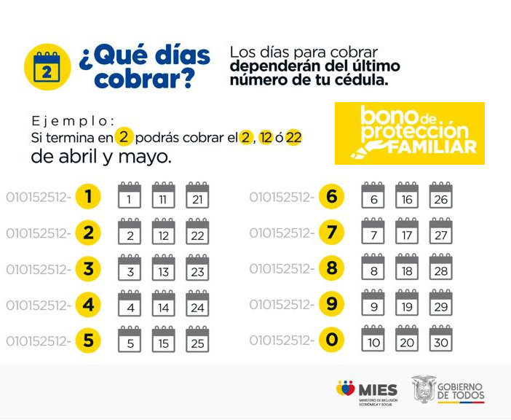

**Figure 1: schedule for the collection of bonds.**

Currently the bonds that are delivered by the Ministry of Economic and Social Inclusion (MIES) are the following:

**Bonds for natural persons**

* Human Development Bonus USD 50
* Human Development Bonus with Variable Component, up to USD 150.

**Bonuses for seniors:**

* Pension My Best Years USD 100
* Pension for Seniors USD 50

**Bonuses for people with disabilities:**

* Pension for People with Disabilities USD 50
* The new Pension A Lifetime USD 100.

In 2007, the Human Development Bond concentrated 1.2 million beneficiaries. In July 2009, Executive Decree No. 1838 determined the increase to 35.00 USD. At the same time, the beneficiaries grew to 1.5 million people, representing approximately 10.57% of the Ecuadorian population; of which 75% corresponded to mothers, counting within the remaining 25% a high margin of young people and adults between the ages of 18 and 39. (Trade, 2014).

Between 2009 and 2012 there was no increase in the perceived value, but there was an increase in subscribers that reached 1.9 million beneficiaries. Finally, in January 2013 an increase in the Human Development Bond was decreed, reaching 50.00 USD per month, which persists to this day, with a variation in the number of members that decreased due to a purification process undertaken by the government leaving out of the program approximately 390,000 people. (Trade, 2014).

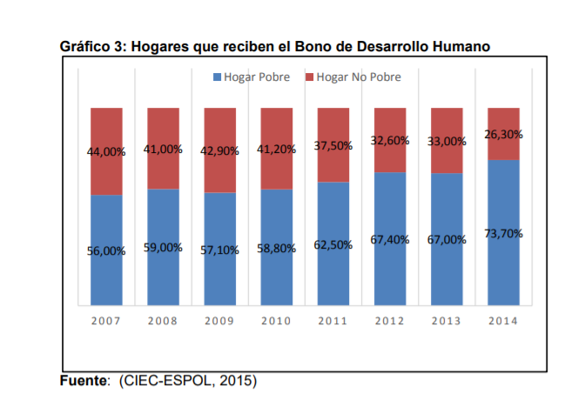

According to the data provided by the Economic Observatory of ESPOL during the 7 years in which the study is carried out, there have been 17.7% of households that managed to get out of the Poverty Line represented in Figure 2 as a decrease in poor households that receive this benefit.

However, an analysis of the information collected shows that there are 73.7% of households that are not poor, but continue to receive the benefit of the Human Development Bond in the urban sectors of Guayaquil, which reveals a deficient allocation of resources.

According to the report presented by ESPOL in 2015, there has been a significant variation in the distribution of the state's economic contribution to the beneficiaries within the last 7 years in which the analysis of Figure 3 is carried out. The result of the purification process shows a reduction of approximately 51.6% of beneficiaries "representatives of the family nucleus" as drafted in Executive Decree 486 as: single mothers with children under 18 years of age.

It is evident that the purging of the official register, as well as the redistribution of resources, positively affected the elderly beneficiaries, who in the same period of analysis increased by 45% the number of subscribers receiving the Human Development Bonus. Finally, people with disabilities also had an increase of approximately 6.4% compared to 2007.

* **ANALYST COMPARISON**

For this process of analysis the first thing will be to examine the objective proposed and more if it requires it, to what we refer to is that the first thing would be to carry out a case study such as how many older adults can receive the solidarity aid bonus, then we would have to create a study on in which areas of the country are the least benefited and so even those who need less in this way will facilitate us the work in the reconstruction of the program since this will not create any disorder and everyone will be able to receive the right and necessary help.

As a next point we will have to separate the elderly by their generate and age since in this way we will be able to attend to the people according to their age range and by their generate thus demonstrating agility when it comes to distributing with the help of the bonuses on the other hand the creation of a program with these characteristics will help people while they are charging to know already in an exact way who they were helps already and those who still do not so it will allow us to carry out the process in a more orderly and concise way.

The next thing would be to plant a series of characteristics such as seeing if that person is suitable to receive the aid bonus from the Ecuadorian government or see if that person receives any special mention or extra help so we can see who really needs the help first and then we can perform an analysis so that all older adults are helped equally.

In conclusion, when creating the program and all the information compiled on how many people were registered, how many are suitable to receive the aid and indicate in which area they need more support for the delivery of government aid bonds will be useful for us to make the decision, since this would opt for the elderly of very low resources.